Current Situation of Different Pollutants

1. SO2

Respiratory symptoms and lung function disturbances especially among risk groups: asthmatic children and adults and Chronic Obstructive Pulmonary Disease (COPD) and bronchitis sufferers.

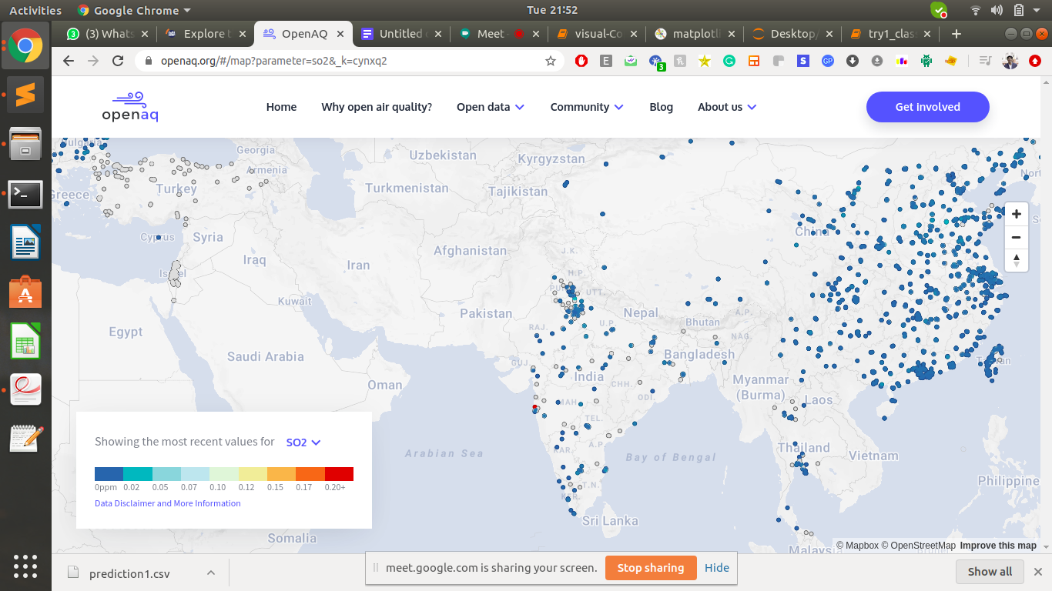

1. PM2.5

These particles of soot, metals, and pollen give smog its murky color. Among vehicular pollution, fine particles pose the most serious threat to human health by penetrating deep .

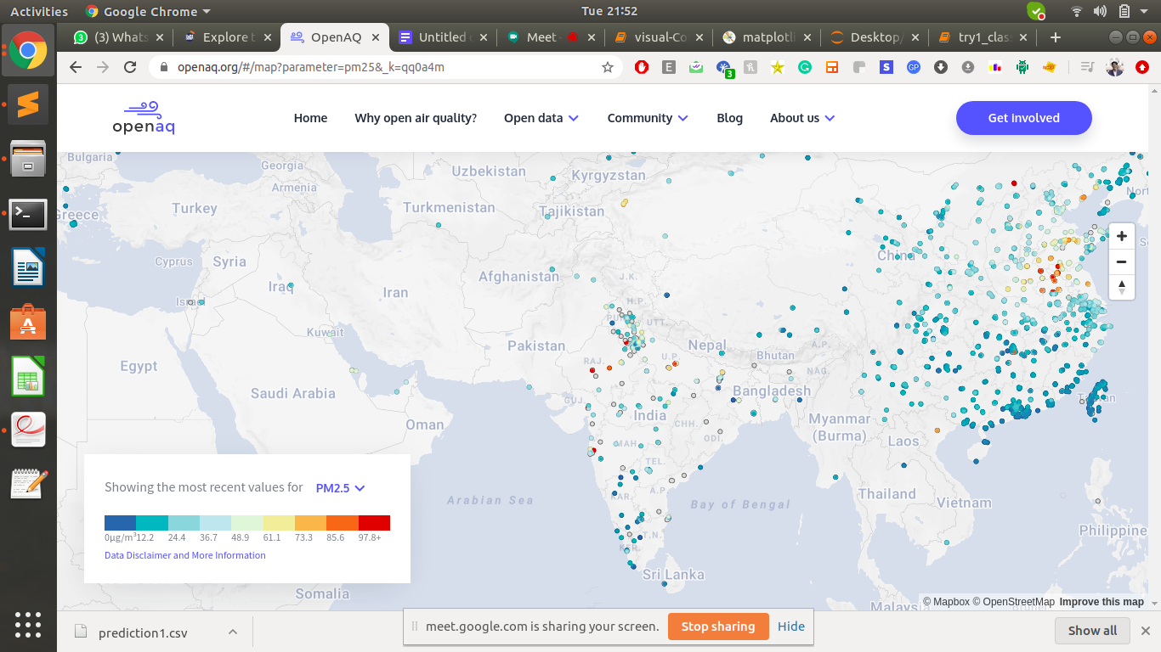

1. PM10

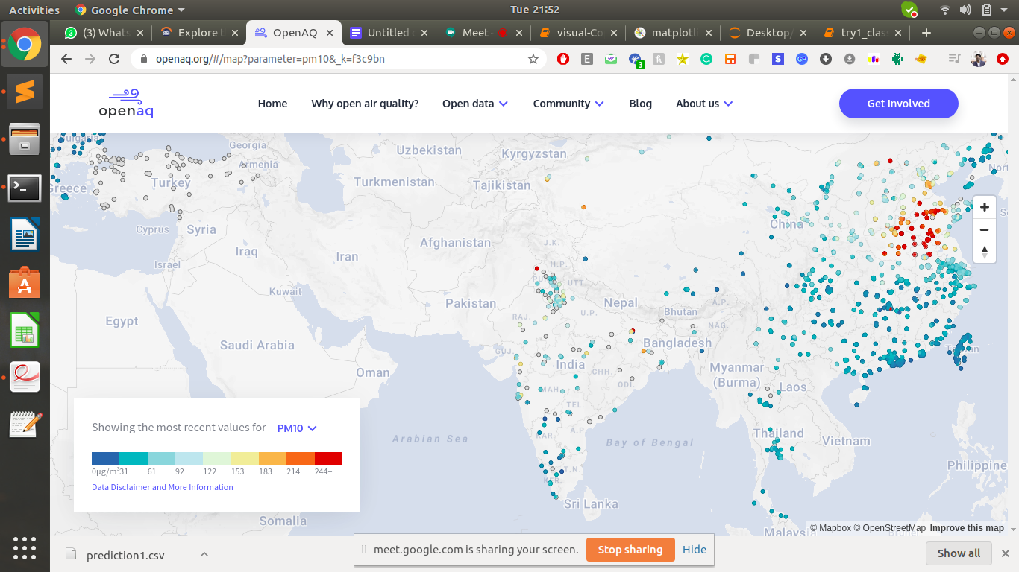

1. NO2

These vehicular pollutants can cause lung irritation and weaken the body's defenses against respiratory infections such as pneumonia and influenza. In addition, they assist in the formation of ozone and particulate matter

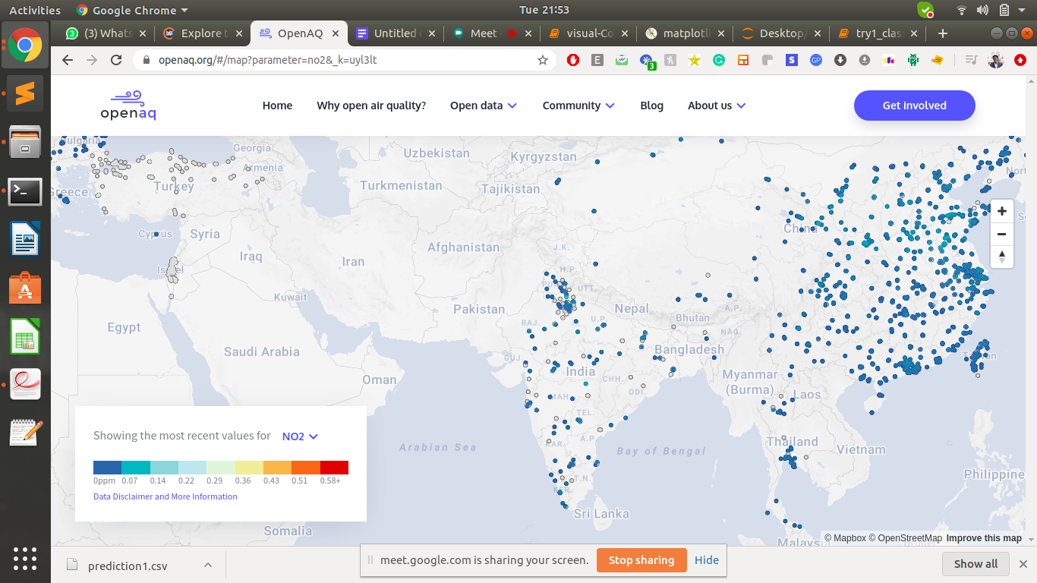

1. CO

Reduced ability of the body to carry oxygen in the blood, causing dizziness, nausea, and headaches; decreased concentration; impaired awareness and physical ability. At risk populations include fetuses and the elderly.

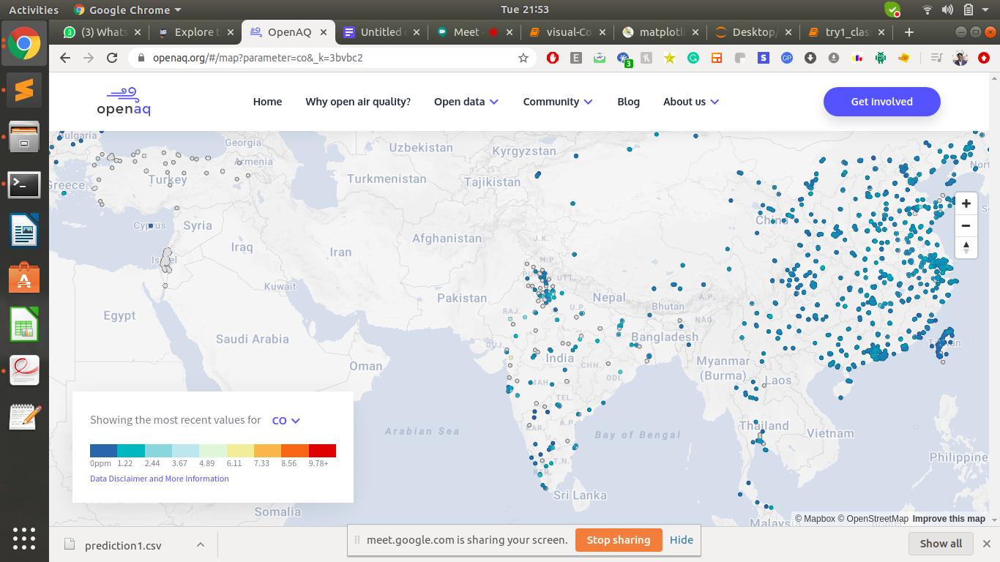

1. BC

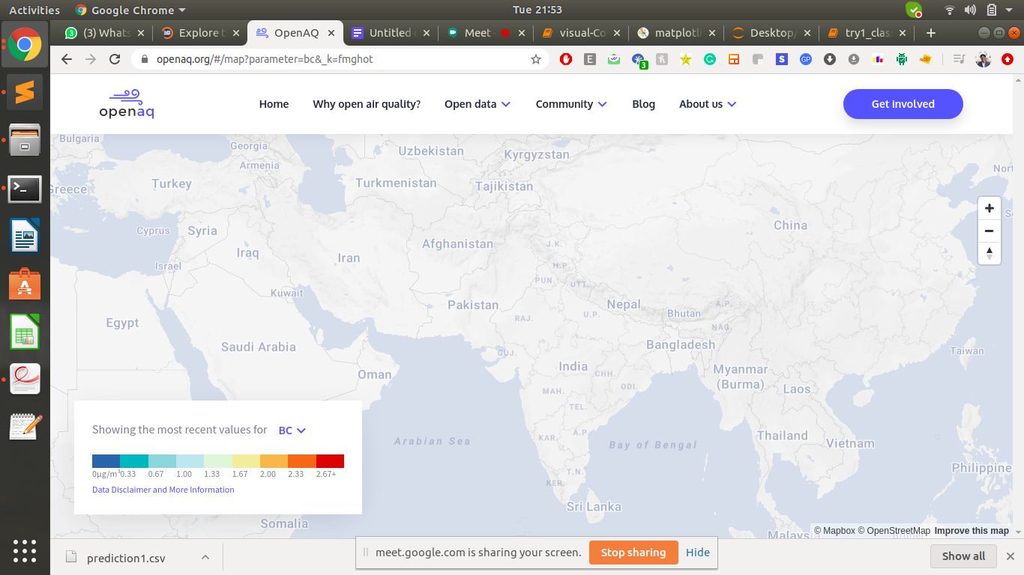

Situation of Different Constituents in 2017

1. PM2.5

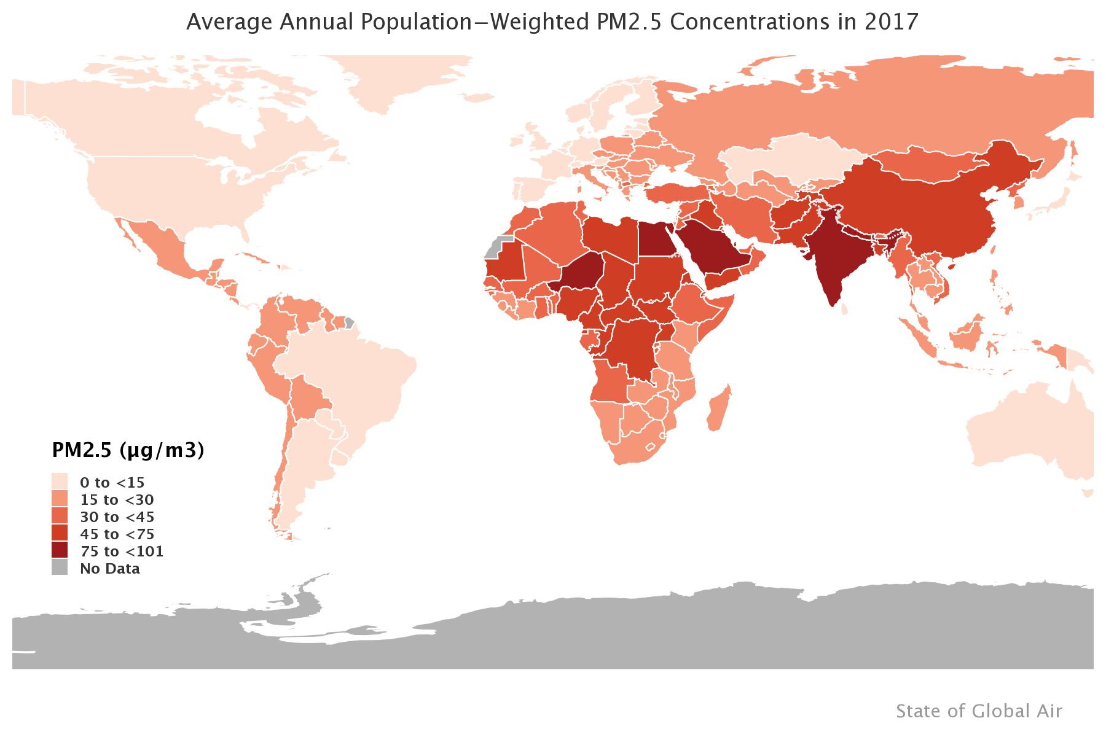

1. Solid Fuels

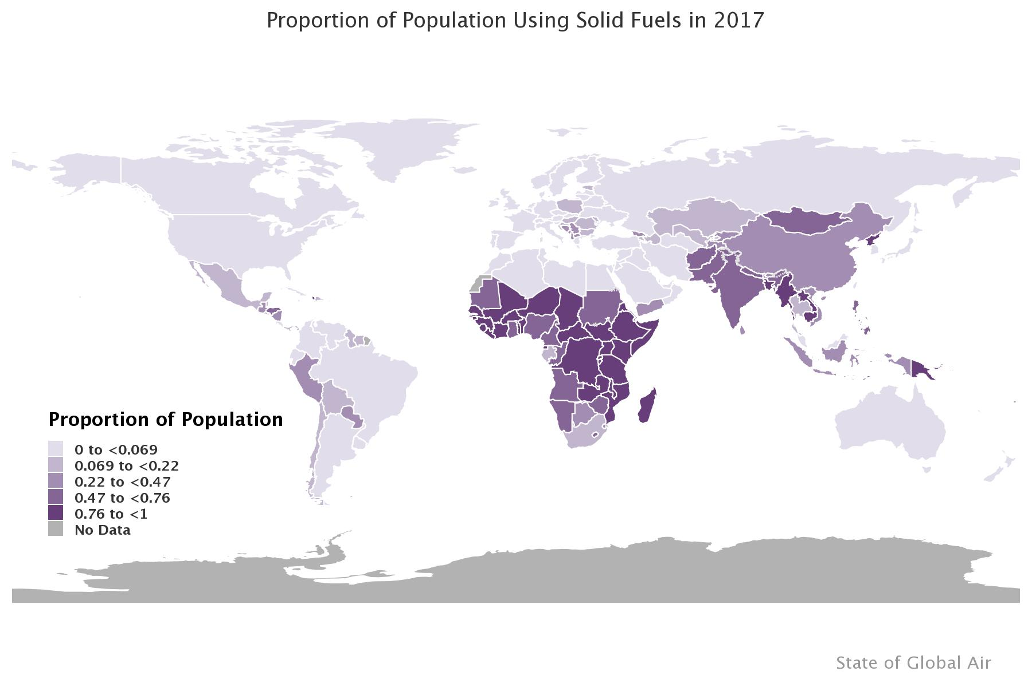

1. Ozone

* The primary ingredient in urban smog, ozone is created when hydrocarbons and nitrogen oxides—both of which are chemicals released by automobile fuel combustion—react with sunlight. Though beneficial in the upper atmosphere, at the ground level ozone can irritate the respiratory system, causing coughing, choking, and reduced lung capacity.

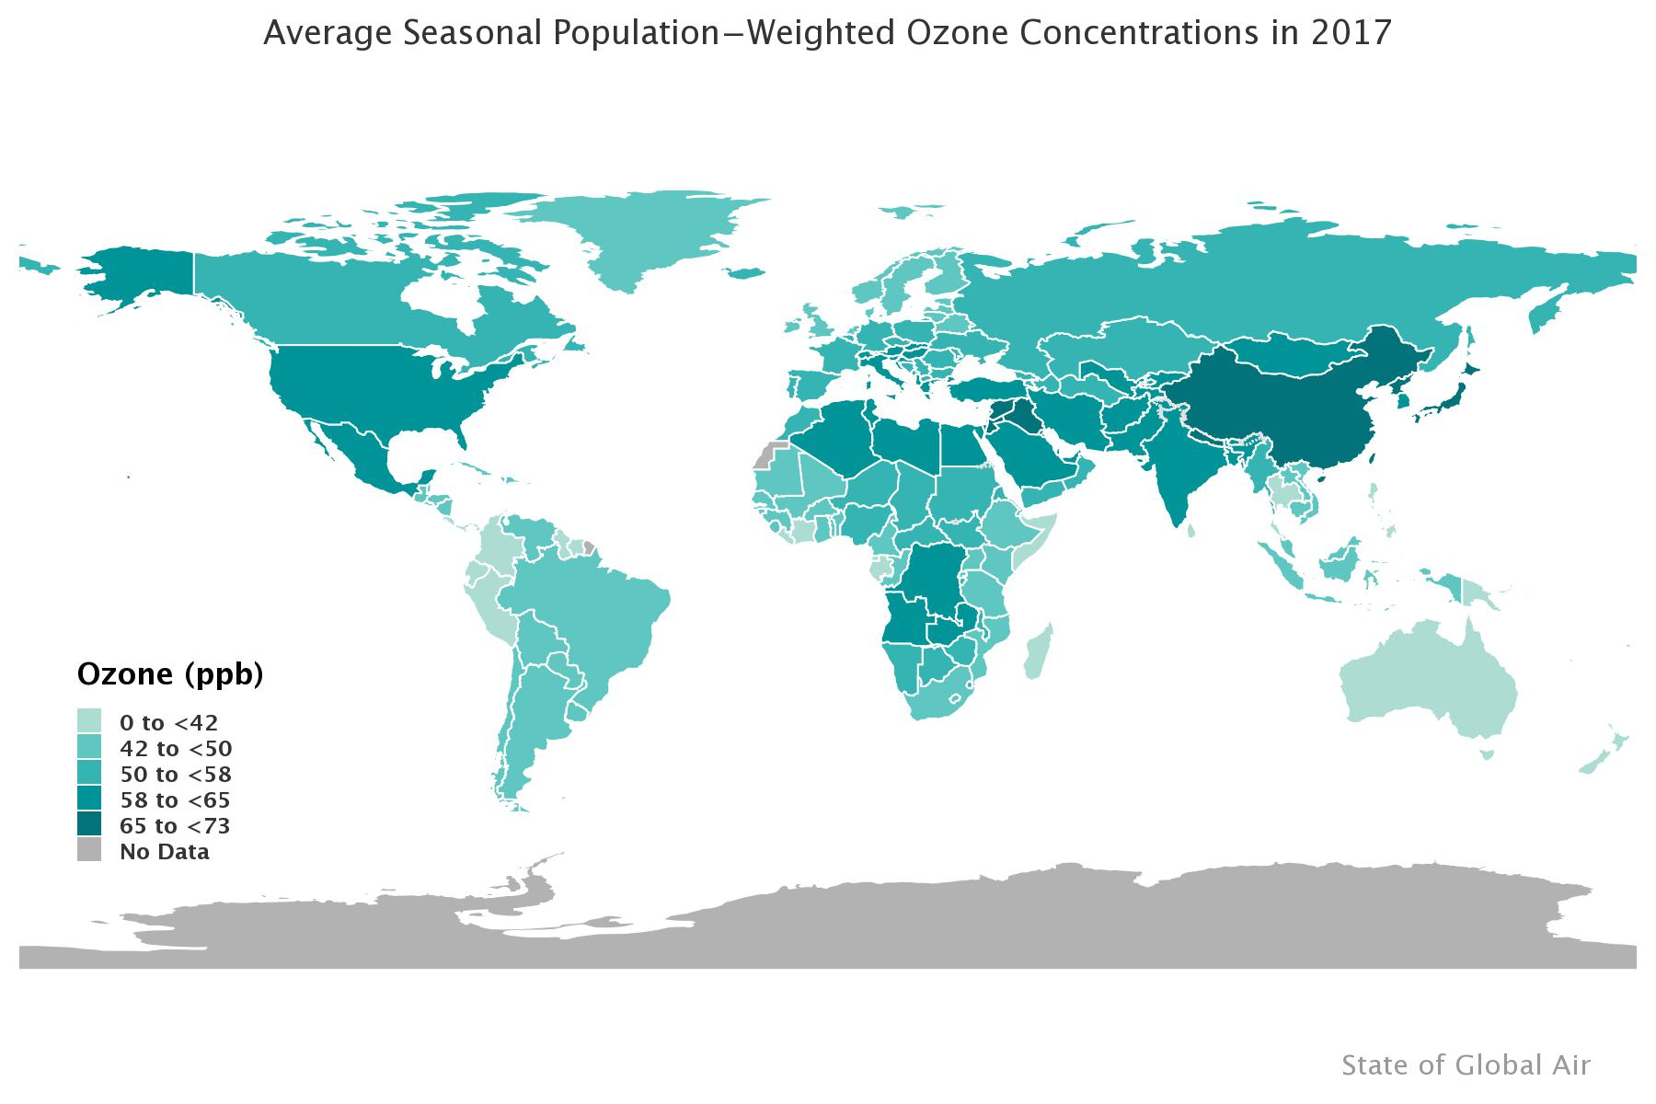

Explanation of Approach –

* **Classification Approach:**

1. Created a x_train data of AQI values (categorical) and trained the model .

2. Treating the AQI values as features of sets of 7 in each row

3. Say, X_train[0] is a row of data from 7 past days and Y_train[0] is the data of the 8th day.

Using this technique, trained the data

4. After the training is done , selected the last 7 days rows for past 7 days AQI values then predicting the 8th day value and using this predicted values to calculate future values by appending in the x_test list.

Note: Converted the AQI values to categories using the function shown in the image in the file.

* **Regression Approach:**

1. Created a x_train data of AQI values (categorical) and trained the model .

2. Treating the AQI values as features of sets of 7 in each row

3. Say, X_train[0] is a row of data from 7 past days and Y_train[0] is the data of the 8th day.

Using this technique, trained the data

4. After the training is done , selected the last 7 days rows for past 7 days AQI values then predicting the 8th day value and using this predicted values to calculate future values by appending in the x_test list.

AQI(AIR QUALITY INDEX)

* The AQI calculation uses 7 measures: **PM2.5, PM10, SO2, NOx, NH3, CO and O3**.
* For **PM2.5, PM10, SO2, NOx and NH3** the average value in last 24-hrs is used with the condition of having at least 16 values.
* For **CO and O3** the maximum value in last 8-hrs is used.
* Each measure is converted into a Sub-Index based on pre-defined groups.
* Sometimes measures are not available due to lack of measuring or lack of required data points.
* Final AQI is the maximum Sub-Index with the condition that at least one of PM2.5 and PM10 should be available and at least three out of the seven should be available.

Working with Dataset [Regression] –

1. Importing

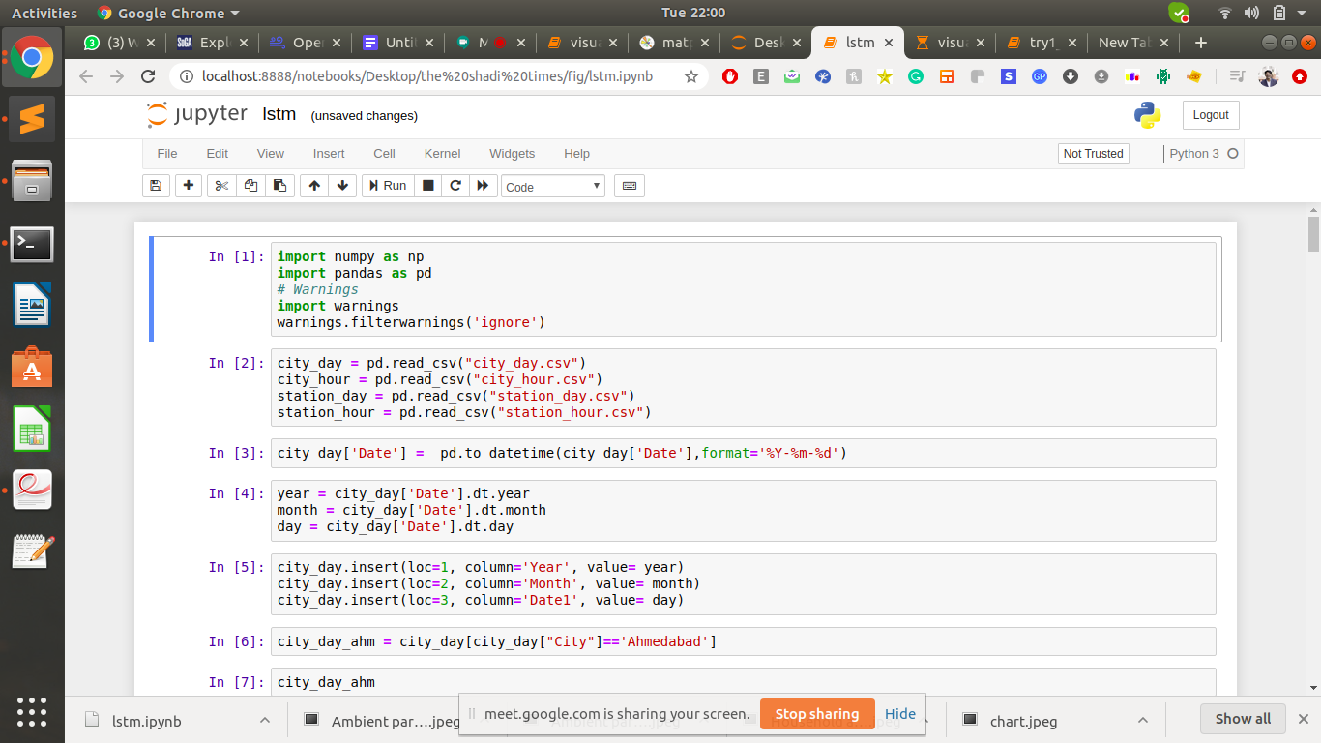

1. Dataset

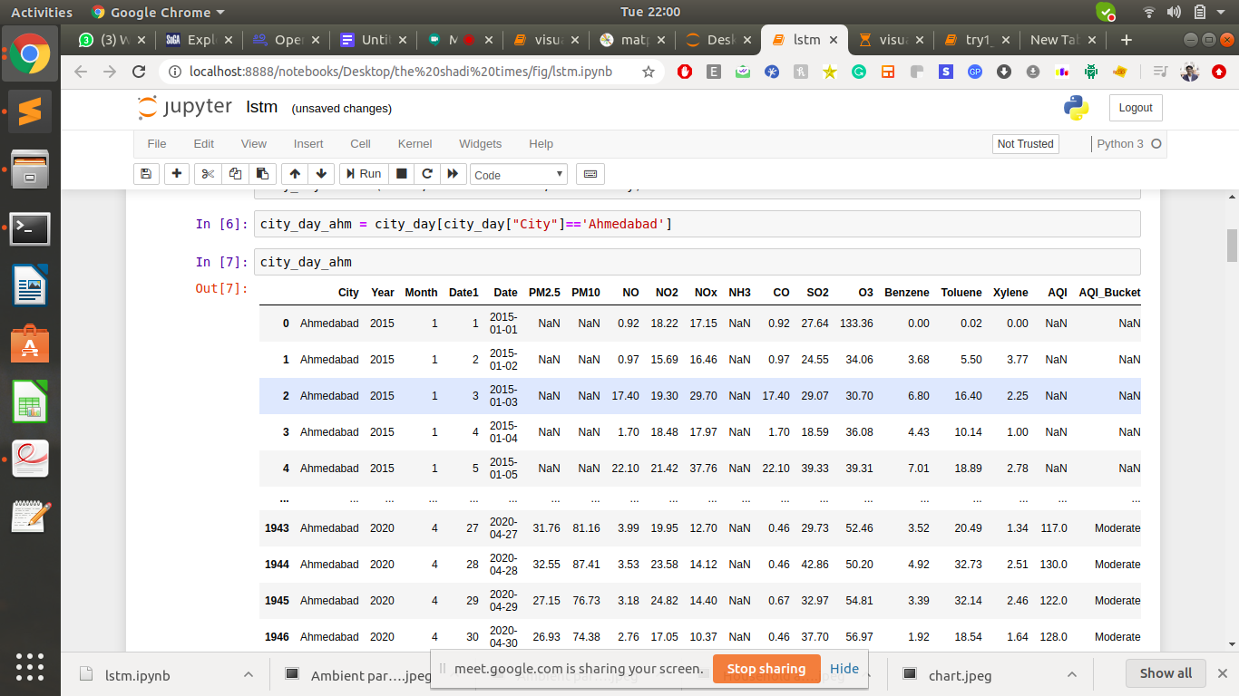

1. Preparing Training Set

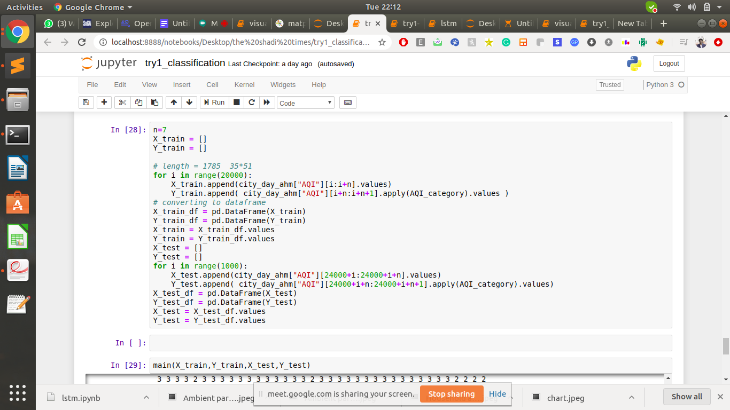

1. Applying Different Regression Models



1. Getting accuracy
2. Linear Regression and Decision Tree

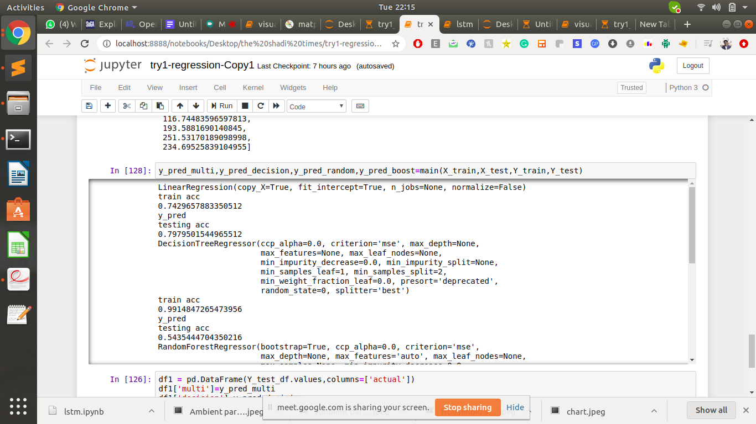

1. Random Forest

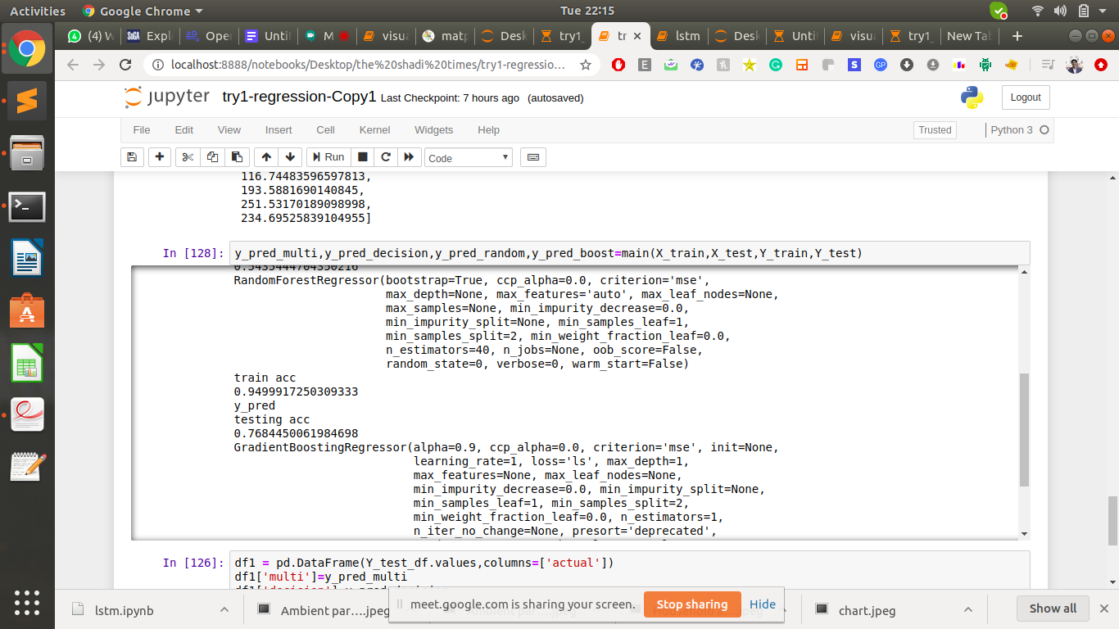

1. Gradient Boost

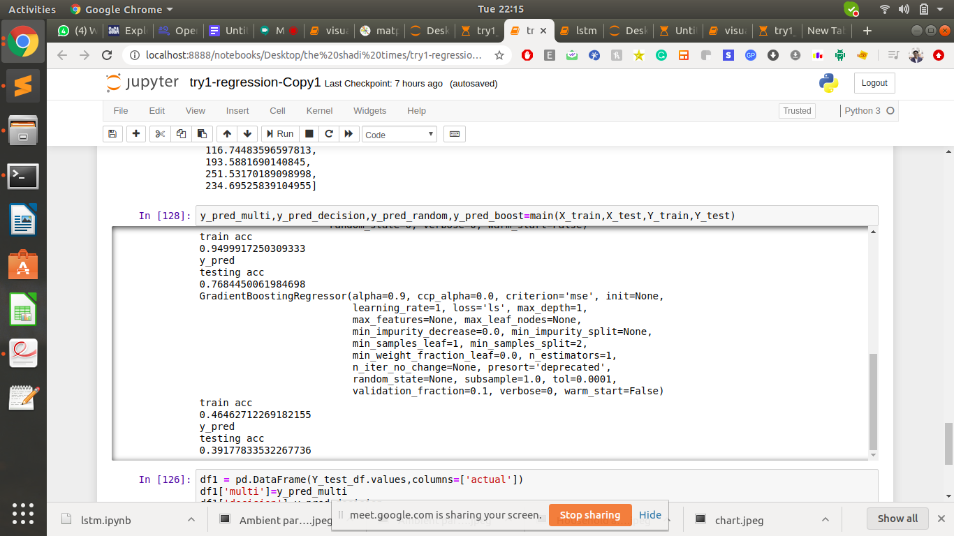

Working with Dataset [Classification] –

[ IMPORTING AND CREATING THE TRAINING AND TESTING DATA REMAINS SAME]

1. Apply Getting accuracy
2. Logistic

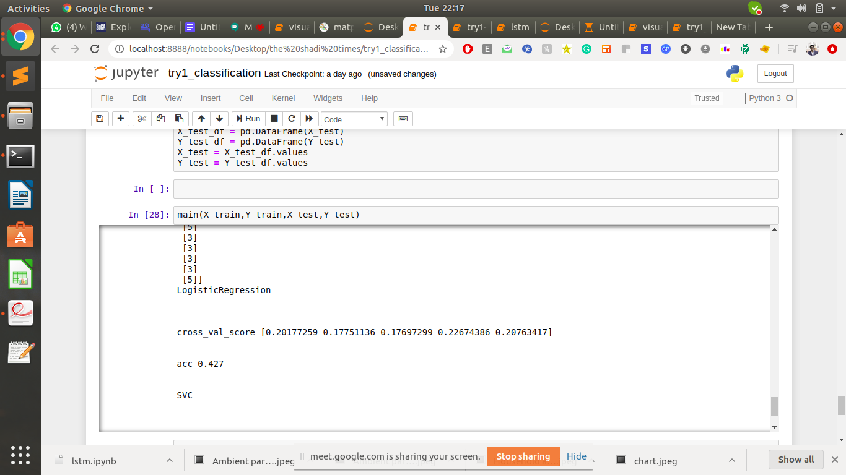

1. Random Forest Classifier



1. Decision Tree Classifier

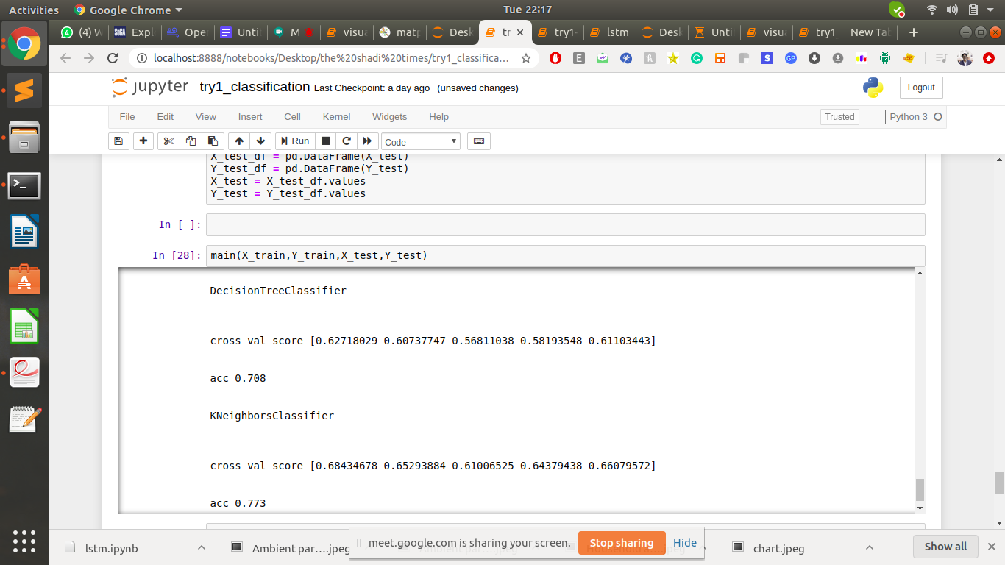

1. K-Nearest Classifier



Working with Dataset [LSTM] –

[ IMPORTING REMAINS SAME]

1. Preparing Training and Testing Dataset



1. Applying the model



1. Analysing the Accuracy

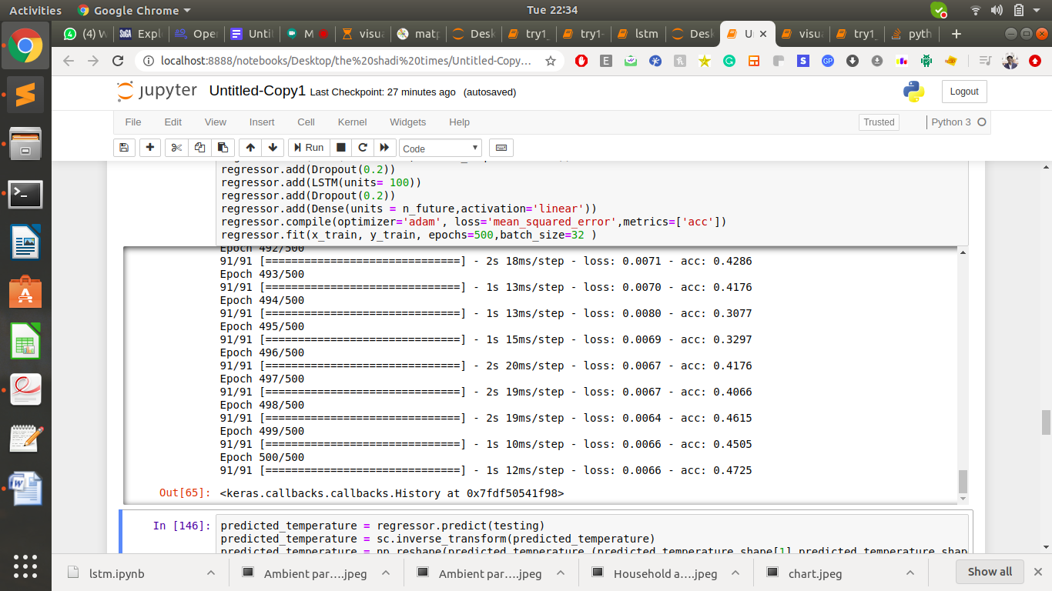

**FACTORS AFFECTING THE TREND**

* 1. The burning of fossil fuels

Industrial operations, coal burning power plants, and companies that rely on trucks and cars, tend to burn a significant amount of fuel. Unless these companies are conscious in their efforts towards improving the environment, they will usually be the biggest culprits in terms of burning fossil fuels. This is why governments are regulating these companies, and requiring them to get various air permits for burning and industrial emissions.

2. Exhaust from factories and industries

* + Manufacturing industries emits large amounts of carbon monoxide, hydrocarbons, organic compounds, and
  + This process thereby depletes the quality of air.
  + Manufacturing industries can be found almost everywhere throughout the world and there is no area that has not been affected by it.
  + Furthermore, petroleum refineries also release many chemicals, such as hydrocarbons and numerous other chemicals, that pollute the air and also cause land pollution ("Conserve Energy Future").

3. Agricultural activities

* Ammonia is a very common byproduct from agriculture-related activities and is one of the most hazardous gases in the atmosphere. Use of insecticides, pesticides, and fertilizers in agricultural activities has grown quite a lot. They emit harmful chemicals into the air and can also cause water pollution.

4. Vehicles Production

* The main cause of vehicular pollution is the rapidly growing number of vehicles. The other factors of vehicular pollution in the urban areas are 2-stroke engines, poor fuel quality, old vehicles, inadequate maintenance, congested traffic, poor road condition and old automotive technologies and traffic management system.
* According to a report released by the Fitch Solutions, vehicle production in India is likely to contract by 8.3 per cent in 2020 following an estimated 13.2 per cent decline in 2019. Covid-19 will also make the transition to BSVI emission norms difficult.

**IMPACT OF THIS TREND ON LIVES OF HUMAN**

* Health Impact of Air Pollution from Industry on human lives:

High concentrations of air pollutants emitted from industrial zones may lead to morbidity and mortality, depending on the types of pollutants and the concentration to which the population living in the region is exposed.

In Haifa Bay, the main pollutants emitted by industry are sulfur dioxide, particulates, nitrogen oxides, carbon monoxide, non-methane volatile organic compounds and ammonia. The health impacts of these pollutants are outlined below:

1. Sulfur dioxide: respiratory symptoms and lung function disturbances especially among risk groups: asthmatic children and adults and Chronic Obstructive Pulmonary Disease (COPD) and bronchitis sufferers.

2 .Particulates: respiratory morbidity and mortality; cardiac morbidity and mortality. Particulates with a smaller diameter cause greater health damage because they penetrate deeper into the respiratory tract.

3. Nitrogen oxides: inflammatory responses in the respiratory system; increased frequency of respiratory symptoms (attacks) among asthmatics and COPD sufferers; damage to fetuses due to exposure by pregnant women.

4. Carbon monoxide: reduced ability of the body to carry oxygen in the blood, causing dizziness, nausea, and headaches; decreased concentration; impaired awareness and physical ability. At risk populations include fetuses and the elderly.

5. Non-methane volatile organic compounds: carcinogenicity in some of the compounds; damage to the liver, kidneys and central nervous system; eye, nose and throat irritation; headaches; loss of coordination; nausea; shortness of breath; allergic skin reactions; fatigue and dizziness.

**Health Impact of Air Pollution from Vechiles on human lives:**

These are some of the consequences of pollution:

(i) Global warming

Emission of greenhouse gases into the atmosphere leads to depletion of the ozone layer and this causes global warming. The result of this is adverse weather that more often than not results in loss of life and property. Global warming is a concern for many major world governments and deliberate efforts have been made to reduce it. With the ozone layer depleted, the harmful ultraviolet rays of the sun can reach the lower surface of the earth and harm humans and other living organisms on the planet.

(ii) Poor quality of air

There are countries where the quality of air is so poor that people wear masks to reduce the amounts of harmful substances inhaled. This is not something to smile about because aside from the fact that you have to walk around with a mask all day, which is not comfortable, there is also the possibility of health complications. Countries that have a high number of old vehicles generally have a problem when it comes to this. It’s the reason why many governments have also banned the importation of vehicles older than a certain number of years.

(iii) Health

These pollutants can lead to lung infection and cancer. As we know, hydrocarbons are not very good for human health. They can cause heart disease, aggravate asthma, damage the central nervous system and make breathing difficult. Fuel spillage can also affect the health of plants and marine life. When left unchecked, these health conditions can cause death. Treating diseases such as cancer requires a lot of money. When the population of a country is mostly unwell, the economy stalls because growth is usually pegged on the ability of people to work and earn income.

(iv) Smog and acidic rain

Nitrogen oxides contribute to the formation of highly corrosive smog that speeds up rusting of vehicles. When nitrogen oxide dissolves in rain, acidic rain is formed. Water harvested from this type of rain cannot be fit for human, plant or animal consumption. These bad effects of vehicle pollution are the reasons why it should be every person’s responsibility to reduce or eliminate environmental pollution. The actions of a small group can put a bigger demographic in harms way.

### SUMMARY

### Impact on Companies

### 1.     The clearest and most immediate business impact of the coronavirus pandemic has been a major disruption to supply chains.

### 2.    The spread of the coronavirus has caused several of the most important tech conferences to be cancelled, likely resulting in numerous missed partnership opportunities.

### 3.    The growing need for remote interactions amid the coronavirus pandemic has highlighted a need for 5G technology, potentially accelerating adoption in the long term.

### 

### Mitigation Techniques

### Companies with supply chains dependent on China might begin to reduce their ad spend as a way to mitigate economic losses.

### Streaming video services are also likely to benefit as people seek out more entertainment or news content.

### Coronavirus-driven event cancellations will spur marketers to explore digital alternatives and more event-like content promotion.

**Trends**

* Going by the testing accuracies we see that Linear and Random forest regression stands out and thus are good for prediction of various trends in cities. Prediction of 100 Days in future has been done by the above model and results (in images) are saved in the below drive link kindly go through it. The folder contains all the pollutant being predicted for all the cities in the dataset.
* Link for the folder -

https://drive.google.com/drive/folders/1YehjdKiWdEHGTK4QLFoq_JmZzxGQTXk7?usp=sharing

* Analyzing the images we find out that organic compound of the air are not affected by the lockdown and other the other remaining pollutant see a decline in the trend. Also going by the trend all the pollutant are going to increase after the lockdown.